CPE301 – SPRING 2019

Design Assignment 1A

Student Name: Itzel Becerril

Student #: 2000478001

Student Email: becerri2@unlv.nevada.edu

Primary Github address: https://github.com/HadidBuilds/hw_sub_da1.git

Directory: DA1A

1. **COMPONENTS LIST AND CONNECTION BLOCK DIAGRAM w/ PINS**

Used the assembler in Atmel Studio.

1. **INITIAL/MODIFIED/DEVELOPED CODE OF TASK 1/A**

Registers before assembling.



1. **DEVELOPED MODIFIED CODE OF TASK 2/A from TASK 1/A**

;

; DA1A.asm

;

; Created: 2/15/2019 12:18:20 AM

; Author : itzel

;

; Replace with your application code

.org 0x0000

START:

LDI R25, 0X10    ;High byte multiplicand = 16

LDI R24, 0X01 ;Low byte multiplicand = 1

;high and low together is 4097

LDI R22, 0X11   ;multiplier = 17

LDI R26, 0 ;set to zero for carry

MOV R27, R22 ;saved iteration for loop

INC R27 ;increment by one to compare to breq

CLR R18 ;resets R18

CLR R19 ;resets R19

CLR R20 ;resets R20

CPI R22, 0 ;compares R22 to 0

BREQ DONE ;if it is equal to 0 then go to done

CONTINUE:

DEC R27 ;dec counter

BREQ DONE ;if not equal to 0 jump to done

ADD R18, R24 ;add

ADC R19,R25 ;add carry

ADC R20, R26 ;add carry

JMP CONTINUE ;jmp back to continue

DONE:

BREAK ;answer should have 011011 = 694649

1. **SCREENSHOTS OF EACH TASK OUTPUT (ATMEL STUDIO OUTPUT)**



REG: R20:R19:R18 = 01:10:11

Execution time at 16MHz/cycles = 9.25us

Verification with high level language:

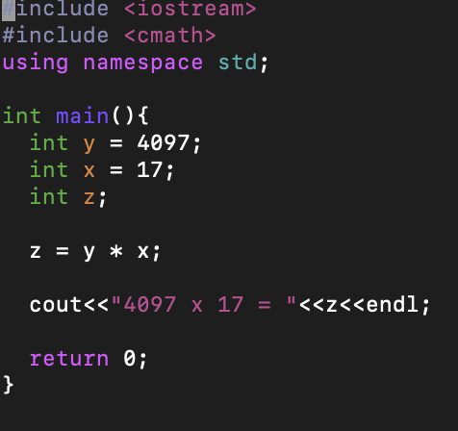

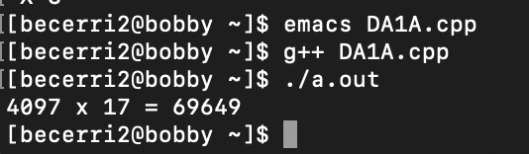

1. **GITHUB LINK OF THIS DA**

<https://github.com/HadidBuilds/hw_sub_da1.git>

**Student Academic Misconduct Policy**

<http://studentconduct.unlv.edu/misconduct/policy.html>

“This assignment submission is my own, original work”.

Itzel Becerril